**Linear motion: revision**

1. Explain what is meant by a scalar quantity and give some examples.
2. Explain what is meant by a vector quantity and give some examples.
3. How long does it take to hear a thunderclap 6.8 km away if the sound wave moves at 340 m/s?
4. It takes a pulse of light 35 microseconds to travel down a 5.0 km length of fibre optic cable. How fast does the light move through the cable?
5. What is the difference between distance and displacement? When is the magnitude of the displacement equal to the distance travelled?
6. A car drives 22 miles north then drives 14 miles south. What is its displacement?
7. A raven flies south for 120 seconds at a speed of 12 m/s, then flies 0.56 km north in 80 seconds.

* What is the total distance?
* What is the total displacement?
* What is the average speed?
* What is the average velocity?

1. What is the acceleration of an object that steadily increases its speed from 6.0 m/s to 18.0 m/s over a 2.0 second time interval without changing direction?
2. What is the acceleration of an object that maintains a steady speed of 24.0 m/s for 6.0 seconds without changing direction?
3. A car that is initially moving at 22 m/s hits the brakes and stops in 5.0 seconds. What is the acceleration?
4. An airplane that is initially moving at 320 m/s accelerates at 3.0 m/s2 for 20.0 seconds. How far does it move during that time period and what is its final velocity?
5. How long does it take a rock to reach a speed of 24.5 m/s if you drop it from a very tall cliff?
6. A baseball is thrown straight upward at a speed of 17 m/s.
7. 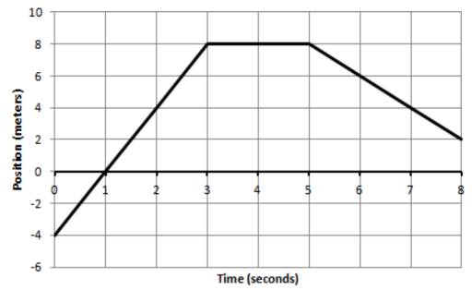The graph below shows the position of an object that is moving along a straight line that runs north-south with north being the positive direction.

* How far does the object move during the first 3 seconds?
* How fast is the object moving at t=1.0 second? 4
* What is the velocity at t=1, 4, and 7 seconds?
* What is the acceleration at t=7 seconds?
* What is the total displacement?
* What is the average velocity?
* Sketch a velocity time graph that shows the same motion.

1. 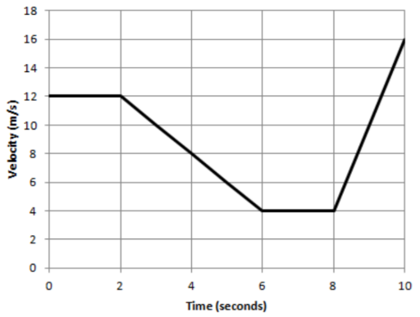The graph below shows the velocity of an object that is moving along a straight line that runs east-west with east being the positive direction.

* How far does the object move during the first 2 seconds?
* How fast is the object moving at t=4 seconds?
* What is the acceleration at t=1, 4 and 9 seconds?
* Which direction is the object moving from 2 to 4 seconds?
* What is the total displacement of the object during the entire 10 seconds?